

Otto-von-Guericke-University Magdeburg Summer Term 2023
Faculty for Computer Science
Seminar Leader: Dr.-Ing Claudia Krull, M.Sc. Pascal Krenckel
Course: Simulation Project

Final Report Part 1: Project/ Documentation

Handed in: 06.07.2023

Madeleine Breitkreutz
Teja Sri Lakshmi Ganesh Balaji Bokka
Rajesh Bhandari
Jannis Römermann
Manu Benny
Atif Harshad

Content
1. Assignment 4
2. Team 7
2. 1 Roles Within the Team 7
2. 2 Assessment Criteria 8
2. 3 Quality Criteria for the Project 8
2. 4 Team’s Goal 8
3. Project Plan 9
4. Conceptual Model 15
4. 1 Planned Experiments 15
4. 2 Assumptions and Simplifications 15
4. 3 Data to be Collected 15
4. 4 Stochastic Petrinet 16
5. Data Collection 17
5. 1 Measuring Procedure 17
5. 2 Data Analysis 17
5. 3 Difficulties and Limitations 23
6. Simulation Program 24
6. 1 Implementation of and differences to the Conceptual Model 24
6. 2 Verification 24
6. 2 Verification of the program 25
7. Validation 26
7. 1 Comparison of city data to measured data 26
7. 3 Sensitivity Analysis 27
7. 2 Comparison of measured data to simulated data 28
7. 3 Scope and limitations 29
8. Experiments 30
8. 1 Experiment Design 30
8. 2 Manipulating the Input 32
8. 3 Guessing values for the 2-way Street Variations 33
8. 4 Effects in Waiting Time 34
8. 5 Effects on Throughput 36
8. 6 Recommendations 38
9. Project Evaluation 39
9. 1 Cost Analysis 39
9. 2 Problems Encountered and Solved for each Milestone 40
Appendix A Tables 42
Appendix B Figures 49

1. Assignment

Team C was to work on the traffic node connecting Braunschweiger Straße, Wolfenbüttler Straße, Schöninger Straße and Rottersdorfer Straße (as seen in Figure 1).
Braunschweiger Straße is separated in an eastern and western section and provides two streets connecting to the intersection.
Braunschweiger Straße coming from the east is a one-way-street leading towards the node. Rottersdorfer Straße is a one-way-street leading away from the node.
In the documentation Braunschweiger Straße East will often be labeled as B(E) for convenance. The same can be said for Braunschweiger Straße West (B(E)), Rottersdorfer Straße (R), Schöniger Straße (S) and Wolfenbüttler Straße (W).
Figure 2, 3 and 4 show different angles if the traffic node to provide a spacial understanding of the location.
The team is assigned to turn the node into a 5-way-roundabout and determine effects on the performance of the node as well as make general improvements to it.

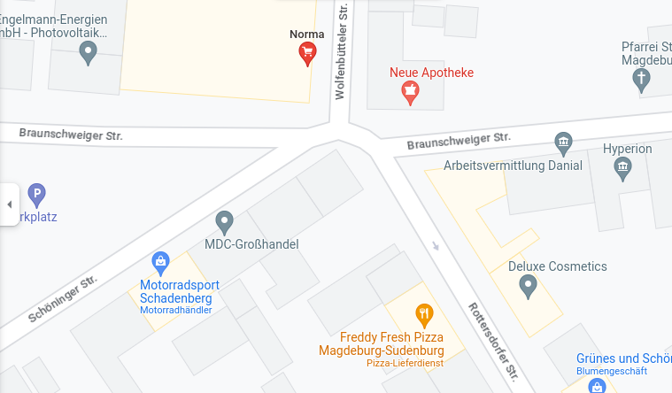
Figure 1: Google Maps depiction of the node

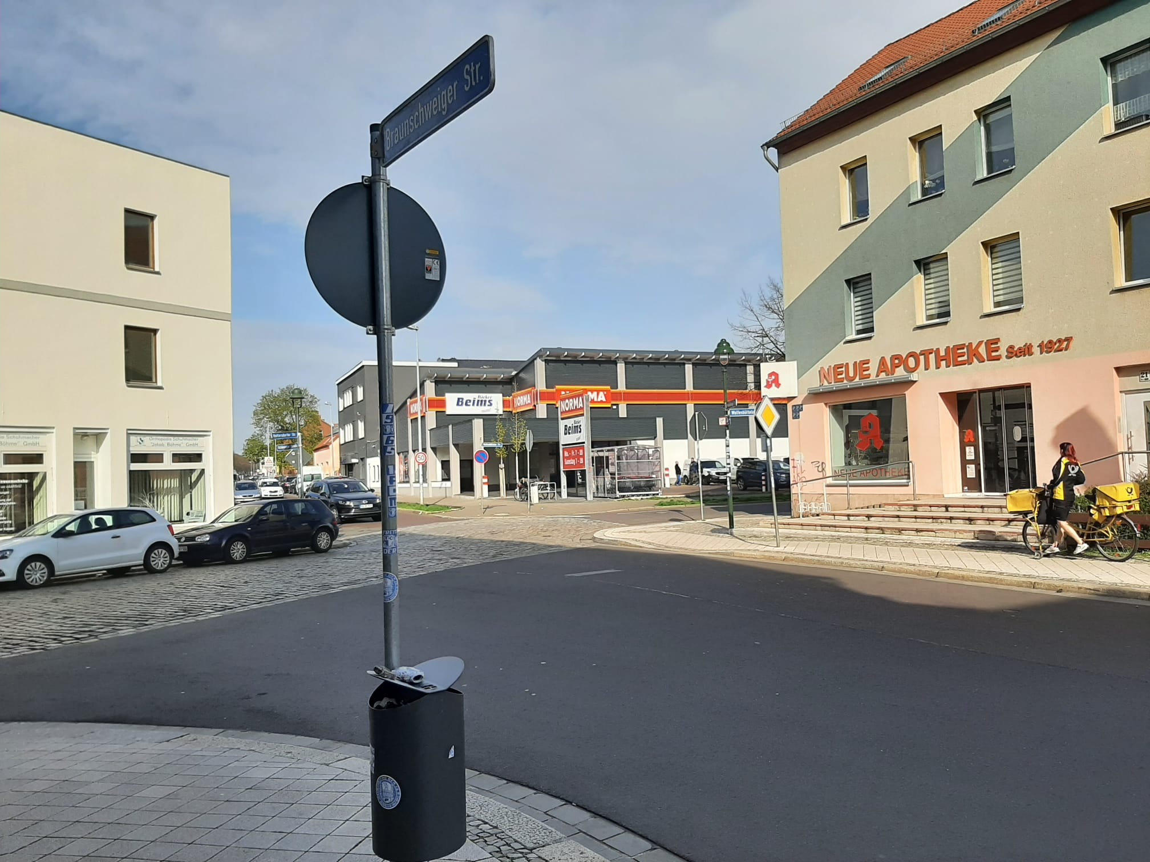

Figure 2: The node from Braunschweiger Straße (East).

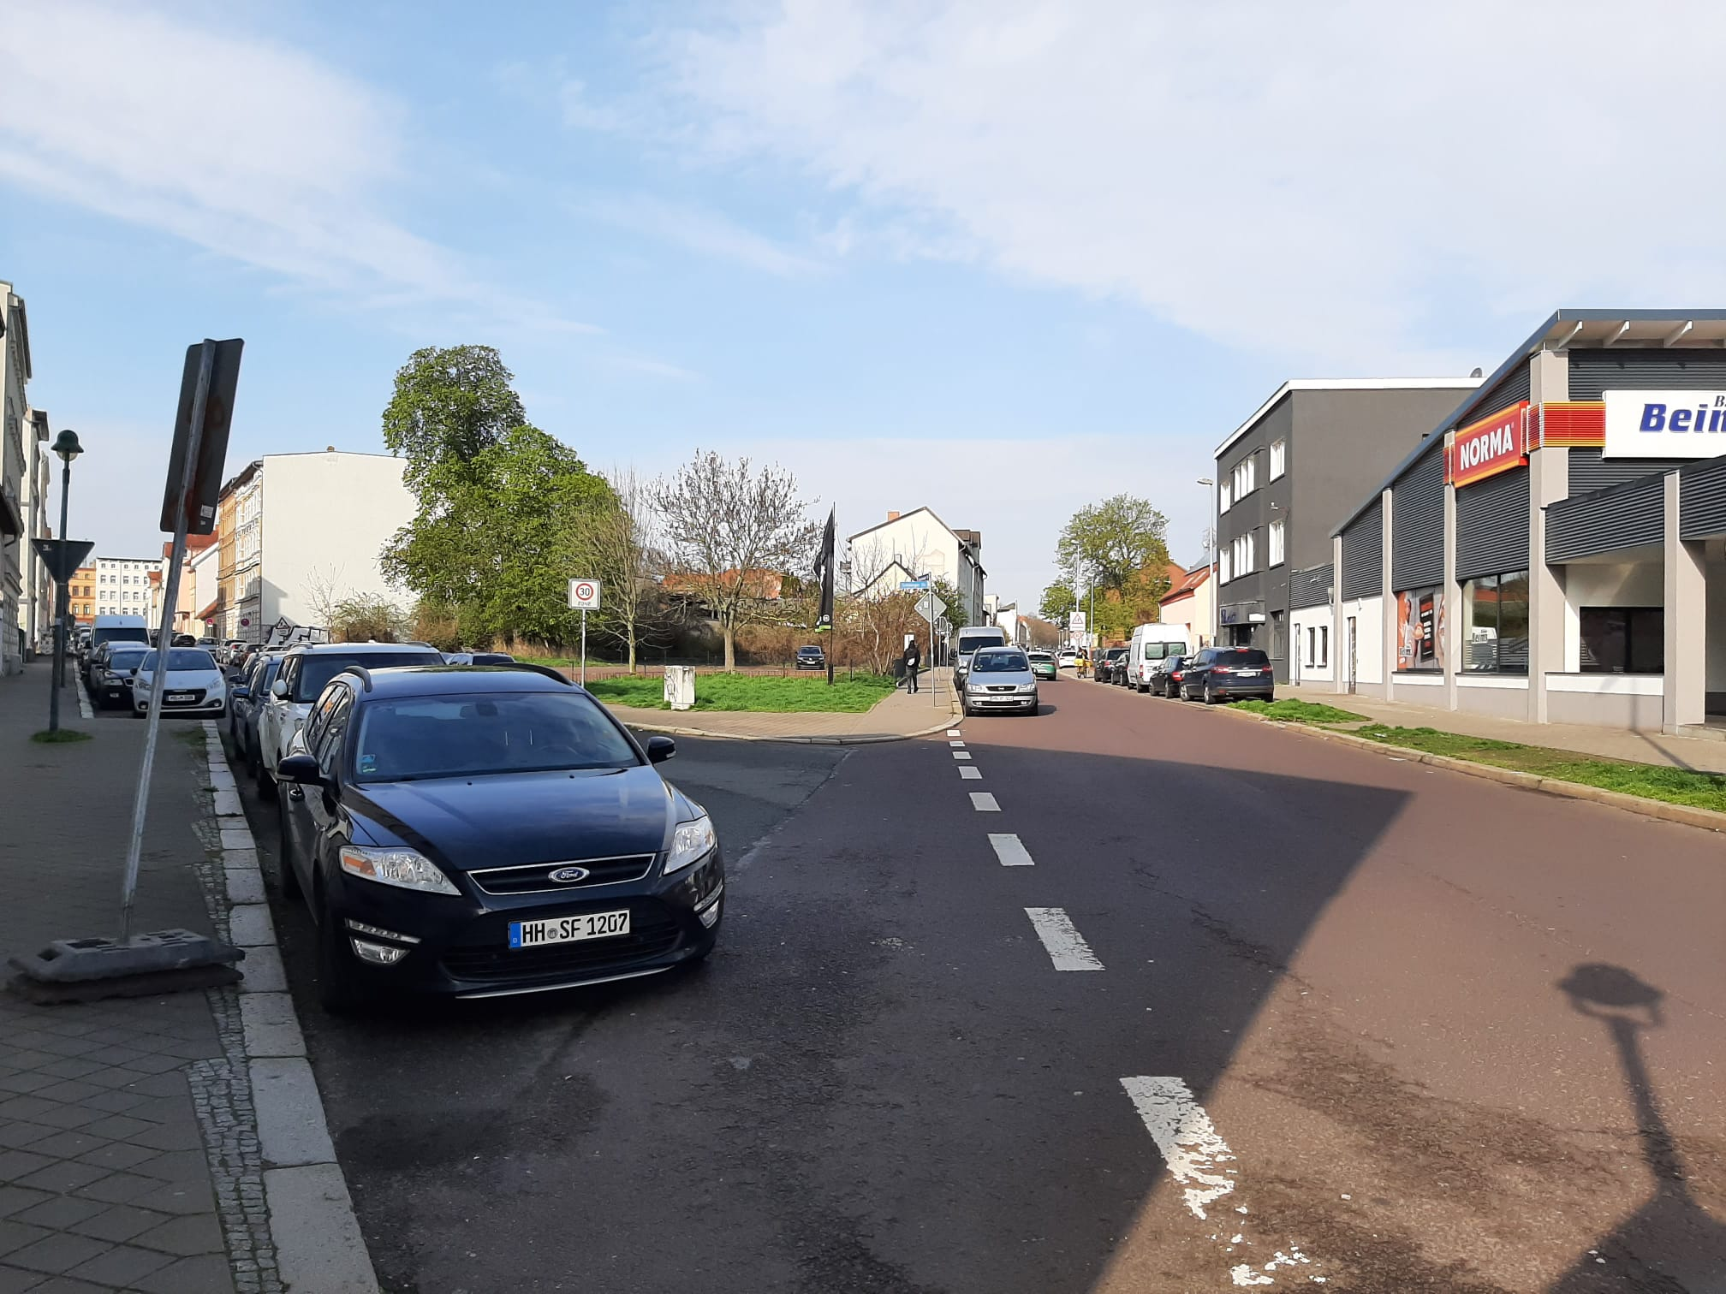

Figure 3: View of Schöninger Straße (left) and Braunschweiger Straße West (right).

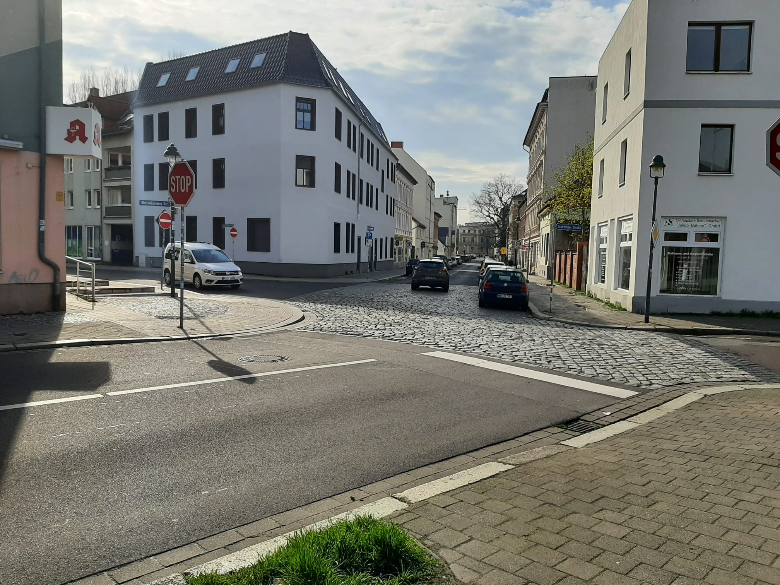

Figure 4: View from Wolfenbüttler Straße with Braunschweiger Straße East (left), Rottersdorfer Straße (middle) the section depicted in Figure 3 (right)

2. Team

2. 1 Roles Within the Team
According to the rules of the course each member of the team had to pick a certain specialized role they would be responsible for. Being responsible was not meant synonymous with taking the whole workload of the task, just overseeing it. Table 1 shows which project member took which role. As a given by the course the roles could be summed up as such:
The teamleader’s job was it to organize the project as a whole, keep an overview and organize team meetings. They were responsible for the parts of the project coming together as one.
The person assigned for the conceptual model was to take responsibility for the design and drawing of the petrinet and keeping it updated.
The input data analyst would organize data collection and see that is is digitalized properly.
The chief software architect was responsible for the simulation model based on the concepts and measurements as well as it’s correctness.
The person taking care of validation and quality control would from the beginning have a critical eye on the other’s steps and contribute ideas what measures to take so that our model could be validated.
The person responsible for the experiment’s design would design the chosen experiments, write appropriate code and from the beginning know what variables we would be interested in.

Table 1: Roles of every team-member
Name | Role
Madeleine Breitkreutz | Team Leader
Teja Sri Lakshmi Ganesh Balaji Bokka | Conceptual Model
Rajesh Bhandari | Input Data Analyst
Jannis Römermann | Chief Software Architect
Manu Benny | Experiment Designer
Atif Harshad | Validation and Quality Control

2. 2 Assessment Criteria
Each team-member will be held to the following standards:
- other members questions, needs or opinions are not to be ignored
- if we can not agree on something we will vote and stick to the majority’s decision
- we will let the others know if we are unhappy with the teamwork and react to it
- we will hand in our work in time for deadlines and meetings
- we will catch up on other’s progress and stay informed
- we will pull our weight reliably so everyone has the same amount of effort

2. 3 Quality Criteria for the Project
The projects quality will be held up by the following factors:
- Conceptual Model is validated by using simple test cases, expert opinion as well as using face validity
- Simulation is validated by performing an input-output-analysis
- Simulation Model is understandable and represents the conceptual model as verified by the use of simple test cases, use of animation as well as common sense.
- Model and experiments run in a reasonable amount of time

2. 4 Team’s Goal
Our project goal is to finish the Simulation project with a good grade for every member. We will apply our mostly theoretical knowledge gained in the Introduction to Simulation course to practical use. We will overcome any hurdle that may be in our way by working together and combining our strengths. We will grow and develop new skills both professional and in teamwork. Everyone agrees to our list of performance criteria to be a valuable member and communicate properly. For our meetings we will be prepared and mind the time planned for each section by the teamleader. We are also willing to shelf our our agenda in favor of more pressing issues that need to be discussed in person.

3. Project Plan

In this chapter we broke down each step of the project into small work packets. None of them was to exceed a week’s work. Table 2 shows the complete project plan. The duration is cumulative for all involved members. For example a teammeating is held by all six members and lasts one and a half hours. So the total duration of a single meeting is nine hours.
Figures 5-8 shows how these tasks are depended on each other with a lot of tasks relying on previous work to be finished. The deadlines are set accordingly.

Table 2: Project Plan with tasks, deadlines and responsibilities as well as duration in hours
Task | Assigned to | Deadline | Duration
Teammeetings |  | 29.06.23 | 90
Meeting 1 | everyone | 20.04.23 | 9
Meeting 2 | everyone | 27.04.23 | 9
Meeting 3 | everyone | 04.05.23 | 9
Meeting 4 | everyone | 11.05.23 | 9
Meeting 5 | everyone | 25.05.23 | 9
Meeting 6 | everyone | 01.06.23 | 9
Meeting 7 | everyone | 08.06.23 | 9
Meeting 8 | everyone | 15.06.23 | 9
Meeting 9 | everyone | 22.06.23 | 9
Meeting 10 | everyone | 29.06.23 | 9
Team |  | 20.04.23 | 20.5
Get into Contact (Discord, Github) | everyone | 20.04.23 | 1.5
General Planning Project | Madeleine | 14.04.23 | 3
General Planning Goals | Madeleine | 14.04.23 | 1
Review of Plans | everyone | 18.04.23 | 5
Research Roles | everyone | 20.04.23 | 5
Prepare Presentation | Madeleine | 19.04.23 | 5
Project Plan |  | 27.04.23 | 23.5
Write down work hours | everyone | 27.04.23 | 1.5
Draft Project Plan | Madeleine | 22.04.23 | 6
Review Project Plan | everyone | 24.04.23 | 6
Ready Hours Excel Sheet | Rajesh, Madeleine | 27.04.23 | 3
Document Results | Jannis | 27.04.23 | 2
Prepare Presentation | Madeleine | 26.04.23 | 5
Presentation | Madeleine | 27.04.23 | 0
Conceptual Model |  | 04.05.23 | 32.5
Research Petrinets on Intersections | Teja, Atif, Manu | 23.04.23 | 3
Logic Road Signs | Madeleine | 22.04.23 | 1.5
Draft Petrinet | Teja, Atif, Manu, Madeleine, Jannis | 27.04.23 | 15
Discussion Petrinet | everyone | 27.04.23 | 3
Verify Petrinet | Madeleine, Jannis | 03.04.23 | 3
Document Results | Jannis, Rajesh | 04.05.23 | 2
Prepare Presentation | Teja | 03.05.23 | 5
Presentation | Teja | 04.05.23 | 0
Data Analysis |  | 25.05.23 | 50
Sheet for Data Collection | Atif | 05.05.23 | 2
Research qq Plot, find Reverse Exponential Distribution | Jannis | 27.04.23 | 2
Decide on Correct Time for Data Collection | Atif | 05.05.23 | 1
Collect Data (1) | Atif, Rajesh, Manu, Teja | 07.05.23 | 9
Collect Data (2) | Atif, Rajesh, Manu, Teja | 13.05.23 | 9
Collect Data (3) | Atif, Rajesh, Manu, Teja | 13.05.23 | 9
Digitalize Data | Madeleine, Jannis | 14.05.23 | 6
Histogramm, qq Plot, Chi Square | Madeleine | 15.05.23 | 5
Document Results | Madeleine | 25.05.23 | 2
Prepare Presentation | Rajesh | 24.05.23 | 5
Presentation | Rajesh | 25.05.23 | 0
Simulation Programm |  | 01.06.23 | 67
Research how traffic is done in Anylogic | Jannis | 20.06.23 | 2
Brainstorm Ideas how to Implement Details | Jannis | 27.04.23 | 3
Decide on Events and Pallet Elements | Madeleine, Jannis, Teja | 10.04.23 | 6
Model Current Node | Jannis | 24.05.23 | 15
Model Roundabout | Teja,Manu | 01.06.23 | 15
Model Two-Way-Street Variations | Teja, Manu | 01.06.23 | 15
Insert Data | Jannis, Teja, Manu | 25.05.23 | 4
Document Results | Madeleine | 28.05.23 | 2
Prepare Presentation | Jannis | 31.05.23 | 5
Presentation | Jannis | 01.06.23 | 0
Validation |  | 15.06.23 | 30
Brainstorm Ideas | Atif | 27.04.23 | 2
Review Given Data | Atif | 27.04.23 | 3
Decide on Data to Measure for Validation | everyone | 27.04.23 | 3
Write and Run Experiments for Validation | Atif | 08.06.23 | 15
Document Results | Madeleine | 14.06.23 | 2
Prepare Presentation | Atif | 14.06.23 | 5
Presentation | Atif | 15.06.23 | 0
Experiments |  | 29.06.23 | 47
Research ANOVA | Madeleine | 04.05.23 | 3
Final Decision on Experiments | everyone | 04.05.23 | 3
Write and Run Experiment 1 | Manu, Teja, Rajesh | 20.06.23 | 7
Write and Run Experiment 2 | Manu, Teja, Rajesh | 20.06.23 | 7
Write and Run Experiment 3 | Manu, Teja, Rajesh | 20.06.23 | 7
Write and Run Experiment 4 | Manu, Teja, Rajesh | 20.06.23 | 7
Analyse and Visualize Results | Jannis | 25.06.23 | 6
Document Results | Madeleine | 01.07.23 | 2
Prepare Presentation | Manu | 28.06.23 | 5
Presentation | Manu | 29.06.23 | 0
Final Report |  | 06.07.23 | 15
Final Version Documentation | Madeleine | 05.07.23 | 6
Print Documentation | Madeleine | 06.07.23 | 1
Prepare Presentation | Madeleine | 05.07.23 | 8
Presentation | Madeleine | 06.07.23 | 0

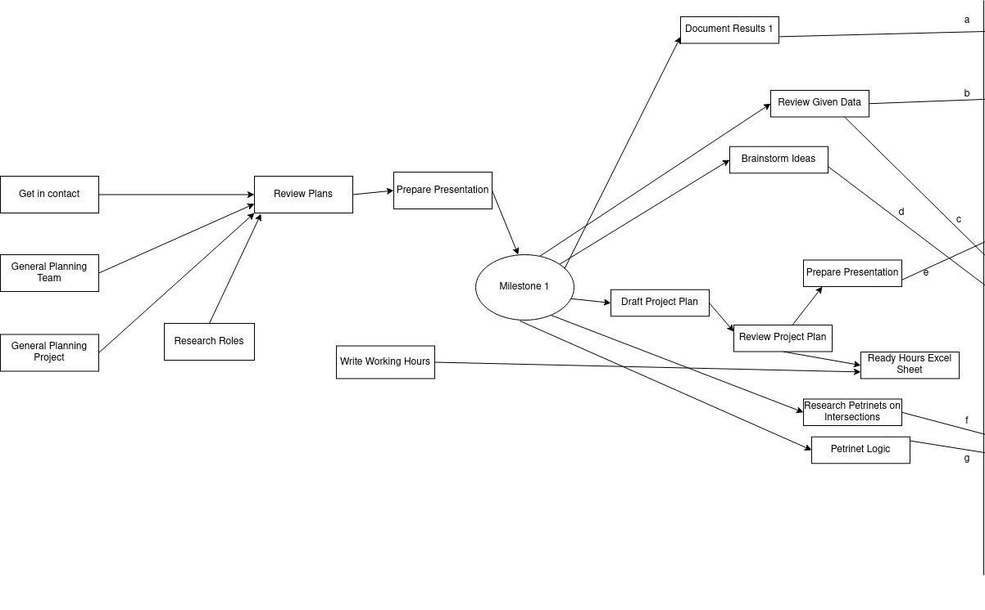
Figure 5: Dependencies of the project plan around milesone 1

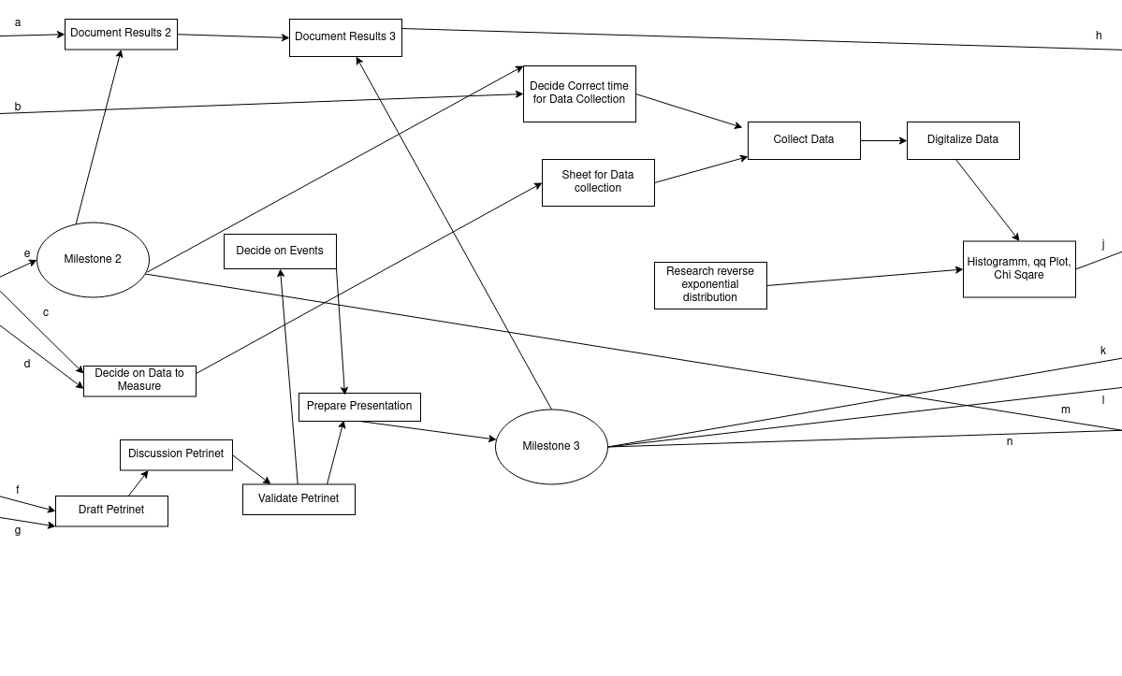
Figure 6: Dependencies of the project plan around milesone 2 and 3

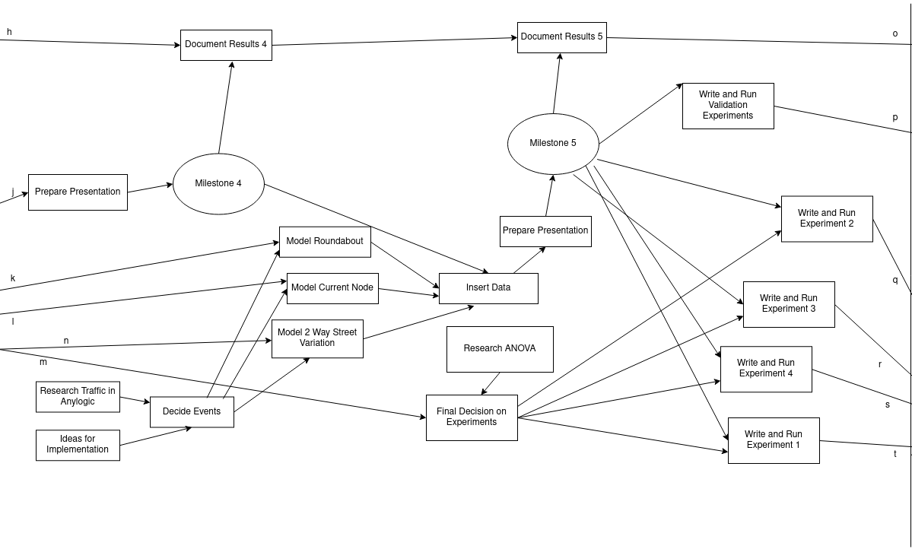
Figure 7: Dependencies of the project plan around milesone 4 and 5

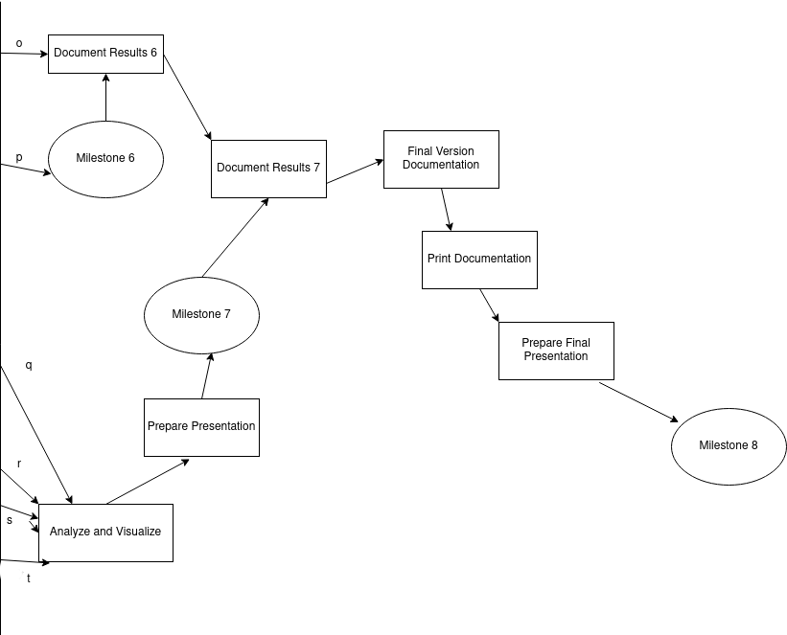

Figure 8: Dependencies of the project plan around milesone 6, 7 and 8

4. Conceptual Model

4. 1 Planned Experiments

The team decided on four experiments: We would turn the intersection into a five-way-roundabout (Experiment 1), which was the primary task given by the city. Additionally we would turn the eastern section of the node into a four-way-roundabout leaving Schöninger Straße and Braunschweiger Straße (West) as they are since this seemed to reflect the spacial properties of the area more (Experiment 2). Further we would test the effect of opening either Braunschweiger Straße East (Experiment 3) or Rottersdorfer Straße (Experiment 4) for traffic in both directions. Further information on the planned experiments can be found in chapter 8 of the report. In each experiment we would look at the effect of the change on throughput and waiting time of the node.

4. 2 Assumptions and Simplifications

For the measurements we are interested in – throughput and waiting time – we do not care if we see a car, a motorbiker or a cyclist. Any vehicle on the street that has to follow the traffic rules as described by the petrinet will be considered a car and therefore be part of the measurements. Also we are completely excluding pedestrians from our model as they are few and they cross the streets randomly and therefore would be difficult to model accurately.
Lastly we assume that every car will drive according to the traffic rules at all times with one exception: Since we rarely see a car treat a stop sign differently to a give-way sign we will do they same in our model not expecting the car to halt when the road is free. However some cars in reality will actually stop for the stop sign so we expect some inaccuracy in the results.

4. 3 Data to be Collected

In order to perform our planned experiments we first and foremost need the inter-arrival times of the cars from every direction leading towards the node so that our simulation will spawn cars in an appropriate matter. To validate our model we will also measure the turning probabilities for each direction and compare them to the probabilities given by the city. Furthermore we will measure waiting time and throughput corresponding to our inter-arrival-times to test if our model produces a similar output, strengthening it’s claim of validity.

4. 4 Stochastic Petrinet

The conceptual model is a theoretical representation of the traffic node to be simulated and experimented on. Here the team has to clarify what assumptions to make in order to answer the questions they decided on and what simplifications they would make for what reasons.
Figure 9 shows the petrinet of the traffic node as drawn by the team.
For each street leading towards the node the arriving cars decide with a certain probability which direction they take. As one reaches the intersection every car that arrives later has to wait in line as all the included streets only have a single lane for each direction. At this point the car may be blocked from moving by any other car at the intersection that has right-of-way. Once no longer blocked the car leaves for the direction it wants to take and by that the petrinet.

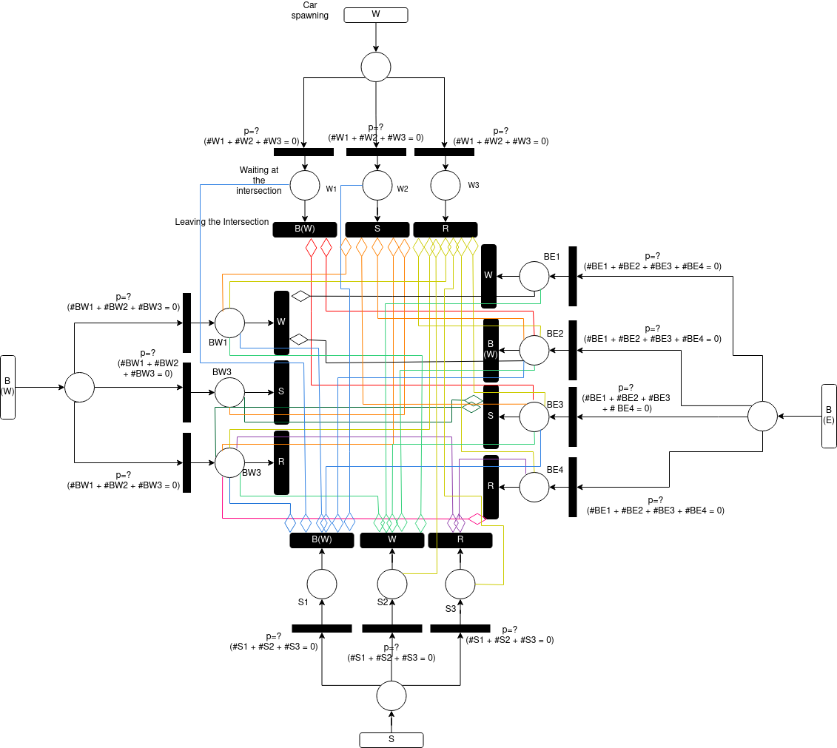
Figure 9: Stochastic petrinet showing the traffic node

5. Data Collection

5. 1 Measuring Procedure

In order to obtain the data needed a total of three measuring sessions were employed covering three hours of real time. For each session three people were involved. Copies of the measuring sheets can be found in the appendix B Figures B1 to B6.
The first two figures show the tallying measuring sheet. A single person was responsible for this sheet. Their task was for each street leading towards the intersection to mark down car’s turning direction. Every fifteen minutes a new tallying sheet was started so that throughput would be determinable from the results.
Figures B3 and B4 show the first of two inter-arrival measuring sheets, figures B5 and B6 the second. They are identical expect for the table heads as one sheet was to measure inter-arrival and waiting times of two of the streets. The other one covered the other two streets. Accordingly two people needed to work with these sheets. Times were measured using the Multi-Timer app.

5. 2 Data Analysis

The raw data of the collection procedure is found in Appendix A and will not be reiterated at this point. Throughput was calculated in fifteen-minute-intervals with a mean of 5.36 cars per minute and confidence interval ranging from 2.65 to 8.06 cars per minute for α = 0.05.
Waiting times can be seen in table 3.

Table 3: Number the waiting time on the left is encountered in each street
Waiting Time in Seconds | B(W) | B(E) | S | W
0 | 259 | 416 | 64 | 148
1 | 0 | 2 | 0 | 8
2 | 0 | 9 | 0 | 19
3 | 0 | 0 | 0 | 14
4 | 0 | 0 | 1 | 10
6 | 0 | 0 | 0 | 2
7 | 0 | 0 | 0 | 1
9 | 0 | 0 | 0 | 1
Inter-arrival times were used to determine the underlying distribution using histograms, QQ-plots and chi-square tests.
Figures 10, 11, 12, 13 show histograms of the inter-arrival times, all indicating an exponential distribution. Figures 14, 15, 16, 17 show QQ-Plots checking the plausibility of said exponential distribution.
For the QQ-Plot of Braunschweiger Straße East (Figure 14) almost all the measured values and expected values lie on a straight 45° line, indicated that the chosen λ = 0,04 is the correct value. It is similar for Braunschweiger Straße West and Wolfenbüttler Straße, for Schöniger Straße the values look a slightly more off. Yet this is the street with the smallest amount of data points.

Finally a Chi² test was used to confirm that we couldn’t disprove our chosen distribution to be the correct one (details shown in table 4). For Braunschweiger Straße East the Chi² accepted the distribution with a chi-value of 11.33 being slightly smaller than the critical value of 11.34. It is reasonable to assume that especially the small values of few seconds were subject to human error in reaction time. This lead to us heaving to oversize the bucket containing these values. More clearly the Chi² tests for Braunschweiger Straße West accepts the distribution (5.15 < 9.21), for Schöninger Straße (5.22 < 6.64) and for Wolfenbüttler Straße (5.99 < 9.2) as seen in tables 5, 6 and 7.

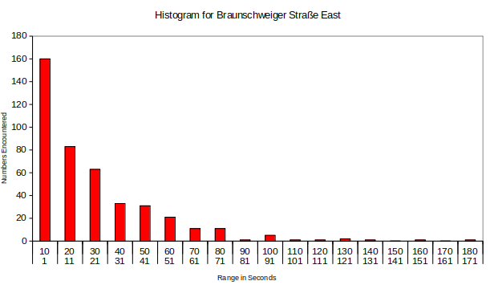
Figure 10: Histogramm showing the distribution of inter-arrival times for B(E)

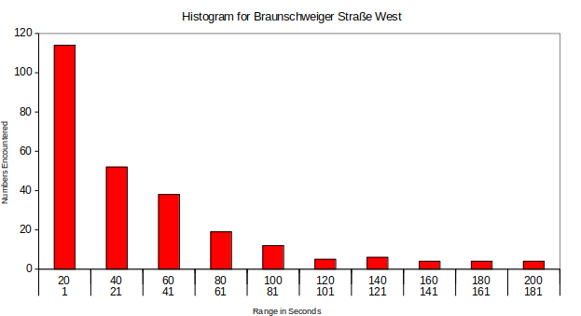

Figure 11: Histogramm showing the distribution of inter-arrival times for B(W)

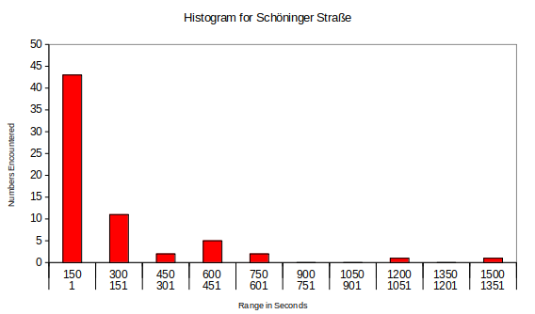

Figure 12: Histogramm showing the distribution of inter-arrival times for S

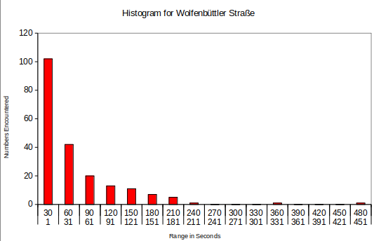

Figure 13: Histogramm showing the distribution of inter-arrival times for W

Figure 14: QQ-Plot for B(E) as an exponential distribution with λ = 0.04

Figure 15: QQ-Plot for B(W) as an exponential distribution with λ = 0.025

Figure 16: QQ-Plot for S as an exponential distribution with λ = 0.005

Figure 17: QQ-Plot for W as an exponential distribution with λ = 0.02

Table 4: Chi² Test for B(E) with exponential distribution λ = 0.04, f = 3, α = 0.01
Minimum | Maximum | Expected | Observed
1 | 10 | 127 | 160
11 | 20 | 84 | 83
21 | 30 | 56 | 63
31 | 50 | 61 | 64
51 | 180 | 47 | 56

Table 5: Chi² Test for B(W) with exponential distribution λ = 0.025, f = 2, α = 0.01
Minimum | Maximum | Expected | Observed
1 | 20 | 94 | 114
21 | 40 | 58 | 52
41 | 60 | 35 | 38

Table 6: Chi² Test for S with exponential distribution λ = 0.005, f = 1, α = 0.01
Minimum | Maximum | Expected | Observed
1 | 150 | 35 | 43
151 | 300 | 16 | 11
301 | 1500 | 16 | 11

Table 7: Chi² Test for W with exponential distribution λ = 0.02, f = 2, α = 0.01
Minimum | Maximum | Expected | Observed
1 | 30 | 85 | 102
31 | 60 | 48 | 42
61 | 90 | 27 | 20
91 | 480 | 40 | 39

5. 3 Difficulties and Limitations

Despite only needing three people to measure in a singe setting finding appropriate times to do so limited the team’s ability to gather a good amount of date. As scouted before the intersection was mostly empty at the majority of times so that we had to concentrate on small rush hours (which still didn’t have lots of traffic). The small sample size will impact accuracy in all the parameters measured.
Waiting time specifically turned out to be not very expressive as the intersection was still empty enough for it to be zero most of the time.
Of course as times were measured by humans a systematic error due to reaction time is to be expected from the data. This mostly reflected in the awkward bucket size for the Chi² Test. So the goodness of fit requires some good will to be acceptable. However results in validation as seen in chapter 7 show that the influence of this should be relatively small.

6. Simulation Program

6. 1 Implementation of and differences to the Conceptual Model

The software used to model and run the simulation is Anylogic. For the timed transitions spawning cars in the conceptual model the Anylogic traffic library offers car sources that can be customized to reflect the distributions we calculated. To reflect the probabilities there is a select output pallet tool. Main streets can be marked accordingly by configuring the crossroad section from the library with Anylogic already implementing the traffic rules. For the main Streets we assigned „Yield”-signs to the Stoplines of the side streets. Figures 18 and 19 show these elements as they look in the program.
Note that for the whole intersection a speed limit of 30km/h will be set even though technically the cars are allowed to go 50km/h. It is expected that the cars will slow down as they come to the intersection.
Apart from implementing details like that which are not part of the conceptual model we made sure to follow it as closely as possible as verified in the following chapter. No special difficulties were encountered. For each incoming street we used a Carsource with the interarrival-rate we calculated. Destinations are defined by CarMoveTo-objects. A car-Agent enters one of those according to the turning probabilities we defined. It saves the time it did not drive to calculate waiting time and we used a car-count to determine the throughput.

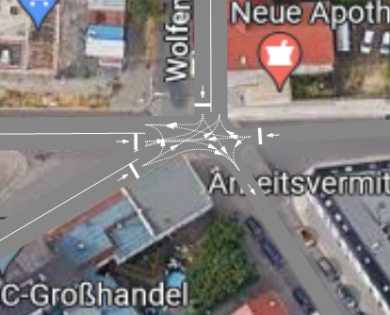

6. 2 Verification

Figure 18: Street and intersection elements from the library implemented

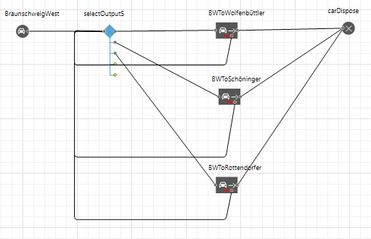

Figure 19: Logic from conceptual model implemented

6. 2 Verification of the program

We used several methods to verify that our conceptual model is properly translated into the Anylogic model.
First of all we used the interactive debugging feature of the software to follow the events of our simulation ans check if they behave as planned. This helped us spot any logical errors.
We used simple test cases to check if cars obey the traffic rules as expected or if there would be a conflict if we flooded the node with cars that had to react to each other.
Furthermore we started with a very simple model and tested it before adding to it and then testing it again to see if it behaved as expected so that unusual behavior had a high chance to be noticed.

7. Validation

7. 1 Comparison of city data to measured data
We were provided with data about the traffic node from 2019 by the city of Magdeburg. To show that our currently measured situation of the node is reasonable we compared the current turning probabilities and throughput with that data.
For the city data not all turning probabilities could be calculated as no counting data for Schöninger Straße was included. The rest of them however are shown in table 8 together with our measured results. They turned out to be similar or even exactly the same for all streets with data points available with the biggest change occurring for Braunschweiger Straße West to Rottersdorfer Straße.

Table 8: Calculated turning probabilities for measured and given data
 | B(E) →  B(W) | B(E) →  W | B(E) →  R | B(W) →  W | B(W) →  R | W →  B(W) | W →  R
Measured | 0.18 | 0.10 | 0.15 | 0.07 | 0.18 | 0.04 | 0.16
Given | 0.23 | 0.11 | 0.14 | 0.06 | 0.27 | 0.05 | 0.14

Similarly throughput for the appropriate time of measurement – in the rush hour between 4pm and 5pm – could be calculated from the city data. An average of nine cars per minute was found for the appropriate time of the day. Note that this is one of the traffic peaks so a throughput higher than that is unlikely. For our measured data an average of five cars per minute was calculated with an 95% confidence interval ranging from three to eight cars per minute. This is slightly smaller than what the city data suggests but in any way we are only dealing with a small difference of less then ten cars per minute. Everything suggests that the situation at the traffic node did not change drastically since 2019 and that our measuring represented the real world situation.

7. 3 Sensitivity Analysis

To check how sensitive the variables we are interested in are to errors in the input we performed a sensitivity analysis for both throughput and waiting time. As figure 20 shows for throughput and figure 21 for waiting time the value of the dependent variable grows rather linearly with the amount of traffic. That means that errors in our input value should only linearly translate to the variables we are interested in, meaning that they should not lead to grossly different results to reality.

Figure 20: Sensitivity of throughput for increasing traffic volume showing linear growth

Figure 21: Sensitivity of waiting time for increasing traffic volume showing linear growth

7. 2 Comparison of measured data to simulated data

For throughput our simulation was successfully validated. We used an Input-Output analysis, taking our calculated distributions for input data and comparing the output of the simulation to the real world results. As seen in figure 22 the mean of the measured data falls into the 95% confidence interval of the simulated data. So we can be pretty confident that or model sufficiently emulated reality in this regard. To calculate confidence intervals we simulated a total 100 runs.

Figure 22: Validation of the Throughput showing the mean of the measured data inside the confidence interval of the simulation

For waiting time our simulation was mostly successful. We again used an Input-Output analysis, simulating a total of 100 runs. As Figure 23 shows the mean of our measured data falls withing the 95% confidence intervals of the simulated data for all streets except Wolfenbüttler Straße. This likely comes from the fact that we decided to depict the stop sign as a yields sign in the anylogic model as we saw most cars treat it that way. However most cars are not all cars and the ones actually stopping at the stop sign in reality may be what cause the difference to the model.
However since the confidence intervals are very small the difference of less than one second seems larger than it is in reality. We would assume that for the practical performance of the system that difference should not matter greatly. We therefore are confident that our model as a total represents the traffic node accurately enough to answer our questions.

Figure 23: Validation of waiting time showing the mean of the measured data inside the confidence interval of the simulation for all streets except Wolfenbüttler Straße

7. 3 Scope and limitations

Since measurement happened on the peak traffic times for the node the simulation is only valid for this worst case scenarios. For any other time of the day the distributions for inter-arrival time would need to be adjusted.
The model was implemented in order to answer specific questions concerning waiting time and throughput of the node. For any other question, especially anything related to pedestrians, the model was not built and therefore not fit to answer. Special needs of certain traffic participants like cyclists were not implemented.
As discussed in the former section the validity of waiting time is impaired at least for Wolfenbüttler Straße. However this should not have a large effect on our results as the difference is a fraction of a second.
For the set goal of this project our data suggests that the simulation truthfully depicts the real-world situation of the intersection. This however is a very specific question this limiting anything that could be stated about validity apart from that.

8. Experiments

8. 1 Experiment Design
Figure 24 shows the design of our 5-way roundabout in Anylogic. Note that we made sure to keep it to scale so it wouldn’t affect our variables. The 5-way roundabout feeds all five streets into the same roundabout. Looking at the intersection in real live we would assume that that would take a lot of construction around the area as the streets don’t come together perfectly into the same space.
To represent how the intersection looks right now we also modeled a 4-way roundabout as seen in figure 25. Here Schöninger Straße and Braunschweiger Straße West join before they lead into the roundabout.
For all models we also looked at the effects of either opening Braunschweiger Straße East or Rottersdorfer Straße for traffic in both directions.

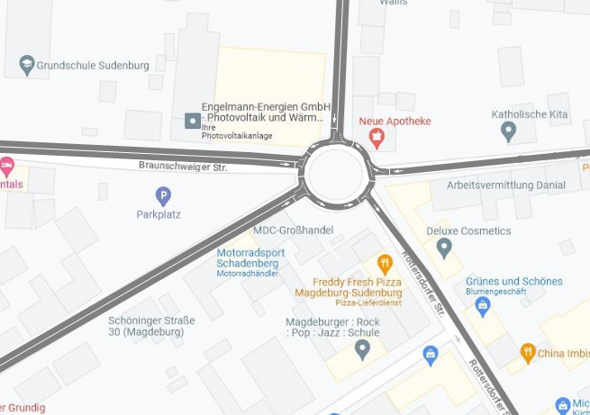

Figure 24: Anylogic Model of the 5-way roundabout

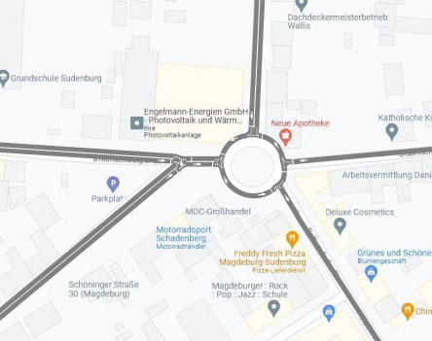

Figure 26: Anylogic Model of the 4-way roundabout

8. 2 Manipulating the Input

We started our experiments using the current volume of the traffic as measured. But as figures 26 and 27 show there is hardly a difference in waiting time and throughput for the three main variations. Because of that we decided that we would perform all or test with an increased traffic volume so that differences in performance were more reasonable. We decided that for the further testing we would use three times as much traffic as we measured.
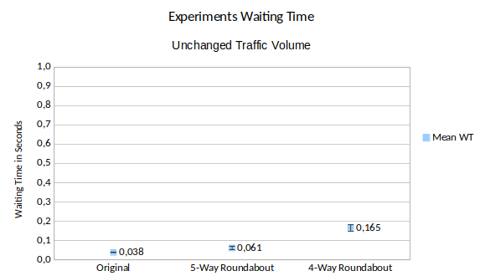

Figure 26: Waiting time(WT) mean and 95% confidence interval(CI) for the three main variations showing negligible differences of a fraction of a second

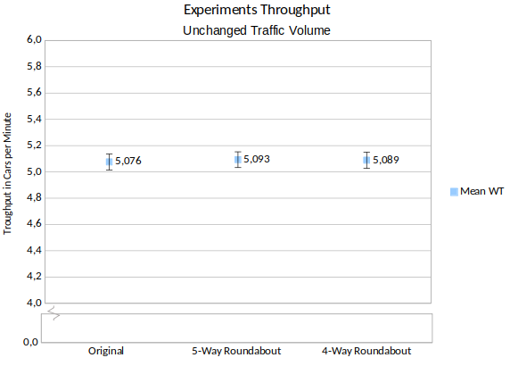

Figure 27: Throughput(Tr) mean and 95% confidence interval(CI) for the three main variations barely showing differences

8. 3 Guessing values for the 2-way Street Variations

To turn Braunschweiger Straße East or Rottersdorfer Straße into 2-way streets we would need to make reasonable assumptions on turning probabilities in both cases and inter-arrival time in the latter. To make an educated guess we plotted probabilities to turn towards a street, to come from a street and inter-arrival time against each other. We noticed that streets that were likely to be turned into were also likely to be the origin of cars and had a smaller inter-arrival time. We chose our values for the 2-way streets so they would fit into that trend.

Rottersdorfer Straße was deemed an average inter-arrival rate of ten seconds. We noticed how Schöniger Straße was less frequented by all other streets so we assumed that Rottersdorfer Straße would turn into it with p = 0.2. With Wolfenbüttler Straße and Braunschweiger Straße West the frequentation differed between the streets so we decided that Rottersdorfer Straße would turn into both with the same probability of p=0.4.

For Braunschweiger Straße East as a 2-way street all the other turning probabilities would be influenced by the new option. We kept it as simple yet close to the original as possible as seen in table 9.

Table 9: Turning probabilities for the 2-way street variation of Braunschweiger Straße East
 | From B(E) | From S | From W | From B(W)
To B(E) | - | 0.3 | 0.2 | 0.43
To S | 0.02 | - | 0.05 | 0.02
To W | 0.18 | 0.15 | - | 0.12
To B(W) | 0.4 | 0.15 | 0.1 | -
To R | 0.4 | 0.4 | 0.65 | 0.43

8. 4 Effects in Waiting Time

As seen in figure 28 for three times the traffic volume the 5-way roundabout had a slightly higher mean in waiting time. More interestingly, the 4-way roundabout had a mean of almost twice the waiting time compared to the other two.
Figure 29 shows the effect opening Braunschweiger Straße East for 2-way traffic would have on the waiting time for the three main variations. The same picture occurs with the current node and the 5-way roundabout performing similarly but the 4-way roundabout showing a mean of more than twice the waiting time compared to the others.
Figure 30 shows the effect of opening Rottersdorfer Straße for both directions. Note that this increases the amount of cars in the system compared to the other two figures so a higher waiting time for everyone is to be expected. Interestingly now the two roundabouts perform similarly while the current node shows a much higher mean for waiting time. However this is only the case if we assume Rottersdorfer Straße will be a main street. As it is highly frequented a lot of cars would have to wait for it. If Rottersdorfer Straße is a side street the waiting time becomes comparable with the roundabouts again.

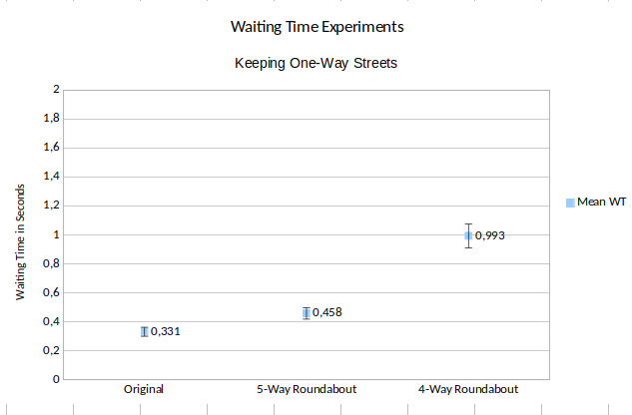

Figure 28: Waiting time(WT) mean and 95% confidence interval(CI) for the three
main variations

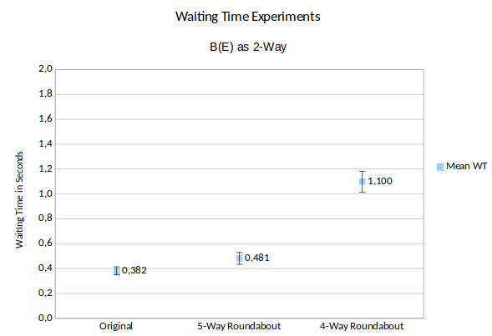

Figure 29: Waiting time(WT) mean and 95% confidence interval(CI) for the three
main variations while opening Braunschweiger Straße East for both directions

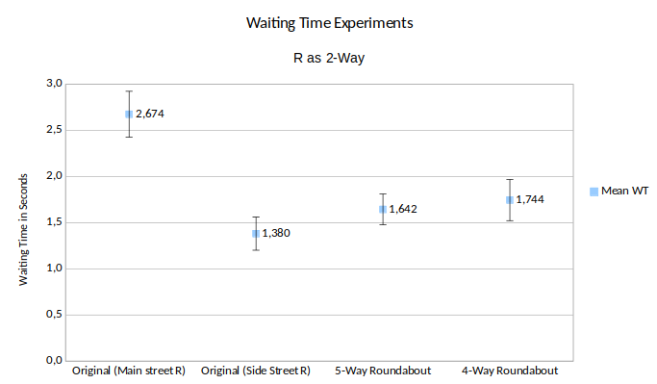

Figure 30: Waiting time(WT) mean and 95% confidence interval(CI) for the three
main variations while opening Rottersdorfer Straße for both directions

8. 5 Effects on Throughput

As seen in figure 31 the current nose and 5-way roundabout perform in a similar way when it comes to throughput while the 4-way roundabout manages to get about half a car less across the node in a minute. This is consistent with the differences in waiting time as more time in that minute is spent waiting.
Figure 32 shows the same situation for opening Braunschweiger Straße East but now showing more clearly how the 4-way roundabout is outperformed. Still the difference in the mean is less than a car.
Interestingly the 5-way roundabout in figure 33 showing the effects of opening Rottersdorfer Straße for both directions shows a much bigger difference. Now the mean for the 5-way roundabout is about two cars higher than for the other models, meaning that the throughput more clearly than the waiting times speaks for a high performance of the 5-way roundabout. Yet again this effect only occurs of Rottersdorfer Straße is a main street and dissappears it it is a side street.

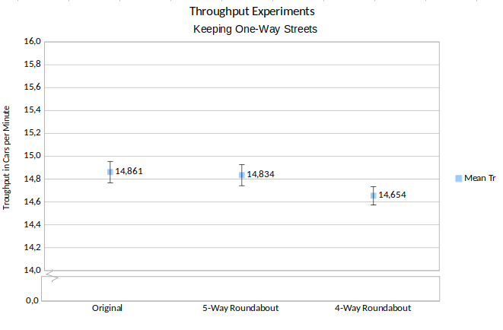

Figure 31: Throughput(Tr) mean and 95% confidence interval(CI) for the three main variations

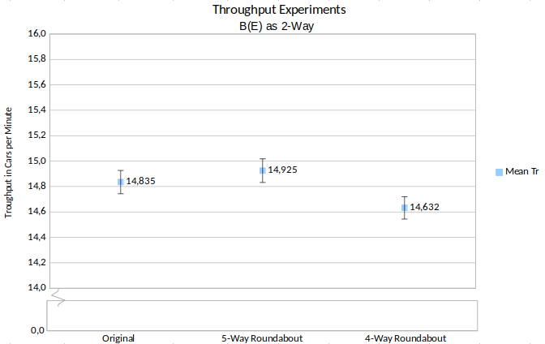

Figure 32: Throughput(Tr) mean and 95% confidence interval(CI) for the three main variations

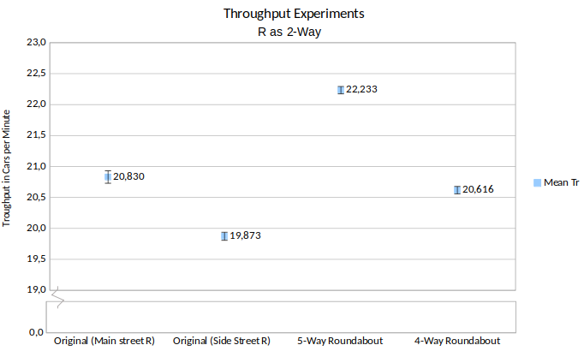

Figure 33: Throughput(Tr) mean and 95% confidence interval(CI) for the three main variations

8. 6 Recommendations

As seen in chapter 8.2 with the current traffic situation waiting time and throughput are pretty much the same for the original traffic node and both roundabouts. So none of these would warrant any changes to the current situation. Yet while not testing for it in any way we believe that turning the node into a roundabout may help safety. Currently the traffic rules applying are hard to process in the brief moment a driver has to determine who has the right of way. With a roundabout it would be simpler ans as we can also tell from our data a roundabout would not worsen waiting time or throughout with the current traffic volume.

If however the city expects a major increase in the traffic volume of the node the situation is somewhat different. As seen in chapter 8.4 the 4-way roundabout worsens waiting time both with the current configuration and when Braunschweiger Straße East is opened for both directions. However the 5-way option is still viable. Opening the street by itself does increase waiting time but not by a lot. However, opening Rottersdorfer Straße and setting it as a main street shows a different picture. As expected all waiting times go up with the increased volume but now both roundabouts are more viable. This effect disappears if Rottersdorfer Straße is a side street.
All in all the 5-way roundabout seems to be the most versatile model for any changes as waiting time is concerned. Especially since here is doesn’t matter which streets are main streets and which are side streets.
If opening Rottersdorfer Straße for both directions was ever discussed it would be logical to assume it should be a main street as it is most frequented. However this leads to higher waiting times in the current node. If so Rottersdorfer Straße should be a side street.

For throughput in chapter 8.5 we also see how the 5-way roundabout performs well in terms of adaptability. It performs at least as good as the current node. Comments about Rottersdorfer Straße for waiting time also apply for throughput.

In conclusion our simulation shows that if the city is planning to do changes to the node a 5-way roundabout would be viable as it is easier to understand and will keep a good performance even with more traffic and other changes occurring.

9. Project Evaluation

9. 1 Cost Analysis
For the project our team had a generous 600 hours to spend. This value was unlikely to ever be reached from the beginning. Even our pessimistic calculations expected us to use less than 400 hours total. In the end we needed 247.5 hours keeping us way under the budget. No member of the team went over the 100 hours reserved for them. Only the final report took longer than we expected. For the future our calculations could be more confident in our abilities. Figure 34 shows our calculated hours and our spent hours. We overestimated the time we would need especially for the Anylogic model as when we made the plan we were not yet aware of the traffic library. We were quite accurate in our estimations for experiments and final report.

Concerning our project plan our progress developed as expected. We usually got a little less done than we would have liked to but the project plan was trying to keep us ahead of the milestones so even when we didn’t manage to get as much work done as we wanted it was always in time for a deadline. Figure 35 shows our progress over the weeks.

Figure 34: Cost of the project in hours sorted by milestone showing differences between expected and actual numbers

Figure 35: Progress of the project in percent over the course of the semester comparing the planned and actual progress

9. 2 Problems Encountered and Solved for each Milestone
The problems arising in Milestone 1 were mostly logistic an nature. With six busy schedules it was hard to find a slot for a meeting. And as the slot was right after the introduction of the course we had to finish the first milestone without even having a meeting with communication between members still substantially lacking.
This rough start led to the project plan in milestone 2 putting a lot of work on a single member of the team. Apart from that estimating the costs for each task was essentially a guessing game leading to us grossly overestimate the time we would need. We also knew from the beginning that the plan was more of a guideline as tasks would be distributed dynamically according to everyone’s individual schedules.
Milestone 3 was when the team started to come together despite communication still being a challenge. This is why the conceptual model had to be redone several times. It was also hard to decide how accurate the model should depict the node while still remaining minimalistic and easy to understand and read.
Milestone 4 was very costly from a time perspective with measuring of the data requiring a lot of attention as well as digitalizing and analyzing it. The inaccuracy of human measurement also led to less than optimal bucket sizes for the Chi² Test. Again many tasks had to be redone several times.
Milestone 5 was all in all unproblematic with debugging being the biggest challenge.
For Milestone 6 we struggled again with communication and with determining the right method to validate our data. We had to be aware of the limitations of the model, like the stop sign acting as a yield sign or the decision not to include pedestrians. It was the only time in the project were some level of tension between the team members was noticeable.
For milestone 7 these problems had been sorted out and there were little to no problems to be reported, namely struggling to find the nicest graphics to present our results and having to rescale the models for the roundabouts so they would cover the correct amount of space.
As work on milestone 9 was done beside the rest of the project there were no special problems encountered here.

Appendix A Tables
Table A1: Values of inter-arrival-time and number of times it occured on the streets
Inter-arrival time in secons | Braunsschweiger Straße (West) | Braunschweiger Straße (East) | Schöninger Straße | Wolfenbüttler Straße
1 | 2 | 12 | 0 | 2
2 | 10 | 40 | 1 | 4
3 | 11 | 32 | 1 | 5
4 | 9 | 20 | 0 | 5
5 | 4 | 12 | 1 | 5
6 | 5 | 13 | 0 | 5
7 | 3 | 12 | 0 | 5
8 | 3 | 9 | 0 | 4
9 | 4 | 7 | 0 | 6
10 | 6 | 4 | 2 | 5
11 | 4 | 11 | 0 | 1
12 | 7 | 9 | 2 | 4
13 | 3 | 8 | 1 | 5
14 | 9 | 12 | 0 | 5
15 | 6 | 13 | 1 | 4
16 | 7 | 9 | 0 | 3
17 | 5 | 7 | 0 | 1
18 | 6 | 3 | 0 | 6
19 | 8 | 5 | 0 | 1
20 | 2 | 5 | 0 | 0
21 | 3 | 8 | 0 | 2
22 | 3 | 4 | 1 | 1
23 | 2 | 4 | 0 | 1
24 | 1 | 0 | 0 | 4
25 | 3 | 0 | 0 | 3
26 | 3 | 0 | 0 | 4
27 | 3 | 0 | 1 | 3
28 | 3 | 0 | 0 | 1
29 | 3 | 0 | 0 | 3
30 | 3 | 0 | 1 | 4
31 | 3 | 0 | 1 | 3
32 | 2 | 0 | 0 | 2
33 | 3 | 0 | 0 | 2
34 | 0 | 0 | 0 | 1
35 | 3 | 0 | 0 | 2
36 | 1 | 0 | 1 | 4
37 | 2 | 0 | 0 | 1
38 | 2 | 0 | 0 | 1
39 | 5 | 0 | 0 | 2
40 | 4 | 0 | 1 | 1
41 | 6 | 0 | 5 | 1
42 | 3 | 0 | 0 | 0
43 | 3 | 0 | 2 | 1
44 | 0 | 0 | 0 | 1
45 | 4 | 0 | 0 | 0
46 | 1 | 0 | 0 | 2
47 | 0 | 0 | 1 | 1
48 | 1 | 0 | 0 | 2
49 | 2 | 0 | 0 | 0
50 | 3 | 0 | 0 | 1
51 | 2 | 0 | 0 | 4
52 | 4 | 0 | 0 | 0
54 | 1 | 0 | 0 | 0
55 | 1 | 0 | 0 | 0
56 | 3 | 0 | 0 | 2
57 | 1 | 0 | 0 | 1
58 | 3 | 0 | 2 | 2
59 | 0 | 0 | 0 | 2
60 | 0 | 0 | 0 | 3
61 | 3 | 0 | 0 | 2
62 | 1 | 0 | 0 | 3
63 | 1 | 0 | 0 | 0
64 | 0 | 0 | 0 | 2
65 | 5 | 0 | 0 | 1
67 | 1 | 0 | 0 | 3
68 | 1 | 0 | 1 | 0
69 | 1 | 0 | 0 | 0
70 | 2 | 0 | 0 | 1
71 | 1 | 0 | 0 | 0
72 | 0 | 0 | 0 | 2
73 | 2 | 0 | 0 | 1
78 | 1 | 0 | 2 | 1
80 | 0 | 0 | 0 | 2
81 | 1 | 0 | 0 | 0
83 | 1 | 0 | 2 | 0
84 | 1 | 0 | 0 | 0
86 | 0 | 0 | 0 | 1
87 | 1 | 0 | 0 | 0
89 | 1 | 0 | 0 | 0
90 | 0 | 0 | 0 | 1
91 | 1 | 0 | 1 | 1
92 | 1 | 0 | 0 | 0
93 | 0 | 0 | 0 | 2
94 | 1 | 0 | 2 | 1
95 | 2 | 0 | 0 | 0
96 | 1 | 0 | 0 | 0
97 | 0 | 0 | 0 | 1
99 | 1 | 0 | 0 | 0
101 | 0 | 0 | 0 | 1
103 | 0 | 0 | 0 | 3
105 | 1 | 0 | 0 | 1
106 | 1 | 0 | 0 | 0
108 | 1 | 0 | 0 | 0
111 | 0 | 0 | 2 | 1
113 | 0 | 0 | 0 | 1
117 | 0 | 0 | 1 | 0
118 | 2 | 0 | 0 | 0
119 | 0 | 0 | 1 | 1
122 | 1 | 0 | 1 | 0
123 | 1 | 0 | 1 | 0
124 | 1 | 0 | 0 | 1
125 | 1 | 0 | 0 | 1
129 | 1 | 0 | 0 | 0
130 | 0 | 0 | 0 | 1
131 | 0 | 0 | 0 | 1
132 | 0 | 0 | 1 | 0
135 | 1 | 0 | 0 | 0
138 | 0 | 0 | 1 | 0
141 | 0 | 0 | 0 | 1
142 | 0 | 0 | 1 | 1
143 | 0 | 0 | 0 | 1
144 | 0 | 0 | 0 | 2
145 | 0 | 0 | 1 | 2
147 | 1 | 0 | 0 | 0
151 | 1 | 0 | 0 | 1
153 | 1 | 0 | 0 | 0
154 | 0 | 0 | 0 | 1
155 | 0 | 0 | 0 | 1
156 | 0 | 0 | 0 | 1
157 | 1 | 0 | 0 | 0
159 | 0 | 0 | 1 | 0
161 | 1 | 0 | 0 | 0
166 | 1 | 0 | 0 | 0
168 | 0 | 0 | 0 | 1
170 | 0 | 0 | 0 | 1
173 | 1 | 0 | 0 | 0
177 | 1 | 0 | 0 | 0
178 | 0 | 1 | 0 | 1
181 | 0 | 0 | 0 | 1
183 | 1 | 0 | 1 | 0
191 | 0 | 0 | 1 | 0
192 | 0 | 0 | 0 | 1
194 | 0 | 0 | 1 | 0
195 | 0 | 0 | 0 | 1
196 | 1 | 0 | 0 | 0
197 | 1 | 0 | 0 | 0
198 | 0 | 0 | 1 | 0
200 | 1 | 0 | 0 | 0
204 | 0 | 0 | 0 | 1
205 | 0 | 0 | 1 | 0
206 | 0 | 0 | 0 | 1
216 | 0 | 0 | 0 | 1
224 | 0 | 0 | 1 | 0
239 | 0 | 0 | 0 | 1
241 | 0 | 0 | 1 | 0
257 | 1 | 0 | 0 | 0
268 | 0 | 0 | 1 | 0
269 | 0 | 0 | 1 | 0
290 | 0 | 0 | 1 | 0
423 | 0 | 0 | 1 | 0
437 | 0 | 0 | 1 | 0
459 | 0 | 0 | 0 | 1
462 | 0 | 0 | 1 | 0
468 | 0 | 0 | 1 | 0
472 | 0 | 0 | 1 | 0
479 | 0 | 0 | 1 | 0
561 | 0 | 0 | 1 | 0
629 | 0 | 0 | 1 | 0
698 | 0 | 0 | 1 | 0
1097 | 0 | 0 | 1 | 0
1408 | 0 | 0 | 1 | 0

Table A2: Numbers of cars turning from Braunschweiger Straße East into each direction in 15-minute intervals
B(E) → B(W) | B(E) → S | B(E) → W | B(E) → R
14 | 0 | 2 | 8
7 | 3 | 4 | 6
8 | 0 | 9 | 13
16 | 3 | 6 | 13
19 | 2 | 11 | 15
10 | 2 | 8 | 8
29 | 1 | 14 | 14
19 | 4 | 11 | 12
17 | 0 | 9 | 9
15 | 2 | 5 | 18
10 | 0 | 4 | 12
12 | 0 | 10 | 17

Table A3: Numbers of cars turning from Braunschweiger Straße West into each direction in 15-minute intervals
B(W) → S | B(W) → W | B(W) → R
1 | 2 | 9
1 | 3 | 14
0 | 2 | 12
0 | 3 | 7
3 | 6 | 18
2 | 9 | 24
1 | 8 | 20
3 | 9 | 12
0 | 7 | 17
2 | 4 | 15
1 | 4 | 15
3 | 6 | 15

Table A4: Numbers of cars turning from Schöninger Straße into each direction in 15-minute intervals
S → B(W) | S -> W | S → R
0 | 2 | 0
0 | 3 | 1
0 | 2 | 1
0 | 0 | 1
1 | 3 | 2
1 | 4 | 3
0 | 6 | 6
2 | 2 | 4
0 | 5 | 0
0 | 1 | 0
0 | 2 | 4
5 | 3 | 5

Table A5: Numbers of cars turning from Wolfenbüttler Straße into each direction in 15-minute intervals
W → B(W) | W → S | W → R
0 | 2 | 13
0 | 1 | 6
1 | 0 | 13
2 | 0 | 9
6 | 2 | 14
6 | 1 | 10
3 | 1 | 15
1 | 0 | 16
4 | 0 | 12
3 | 2 | 18
3 | 0 | 18
8 | 2 | 14

Appendix B Figures



Figure B1: Front page of the tallying sheet Figure B2: Back page of the tallying sheet




Figure B3: Front page inter-arrival sheet 1 Figure B4: Back page inter-arrival sheet 1




Figure B5: Front page inter-arrival sheet 2 Figure B6: Back page inter-arrival sheet 2

